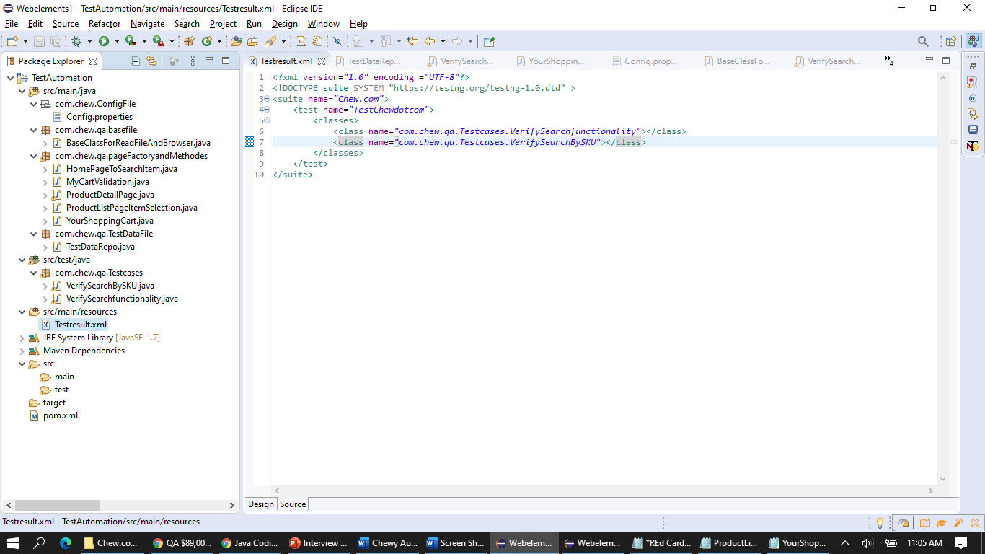

Screen shot is for how Page Object model has been implemented.